Difference between tuple and list

List: It is same as arrays in c language and it is a group of elements which contains with different data types.It always represent with in [] and list elements are separated by comma(,).

List elements are used using index starting with 0 and in reverse index starting with -1

List allows duplicate elements. And it is changeable

EX:

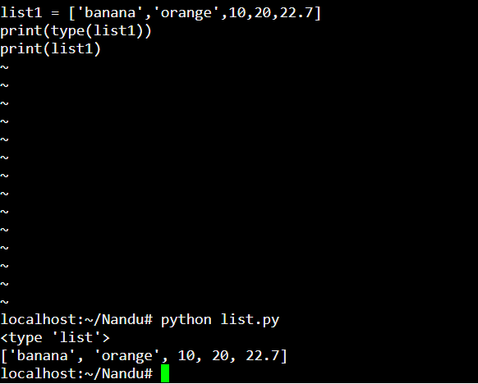

Methods :

1.Length : it indicates the length of the list.

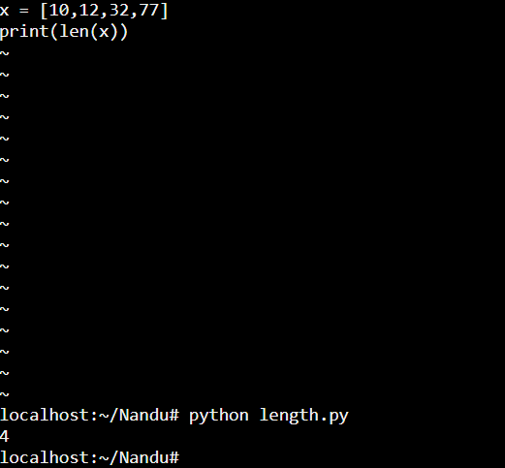

2.Append : add elements every time at end of the list.

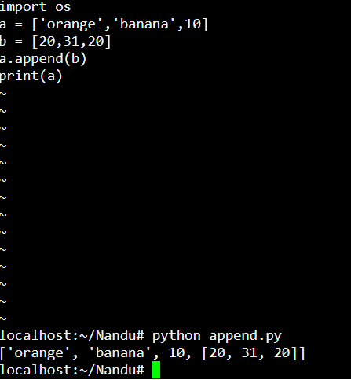

3.Extend : add more than one value/list elements at end of the list.

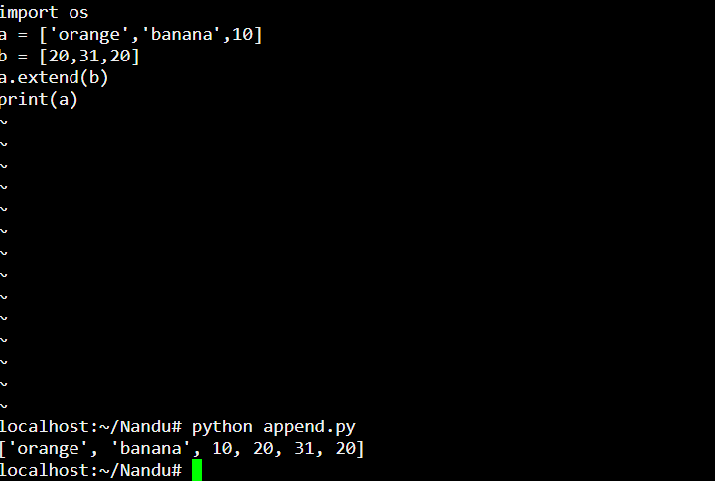

4.Clear : to clear the elements in the entire list.

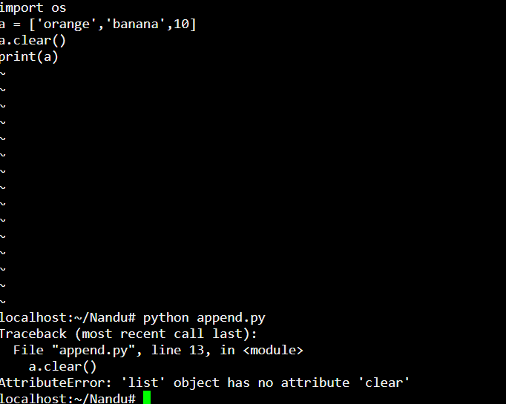

5.Insert : inserting the value/element in the list in a particular position by giving the indexing position.

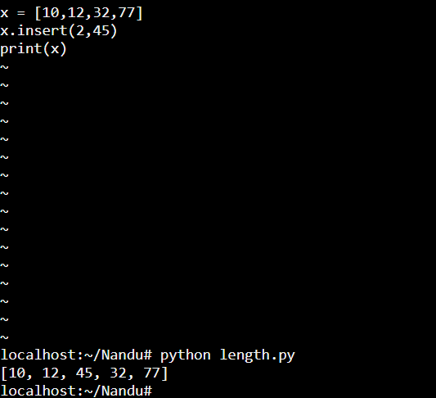

6.Count : it counts the given number

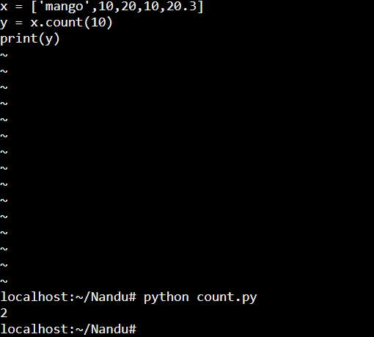

7.Index : it gives the index position of a given number ,we need to give particular element to know the index position of that element.

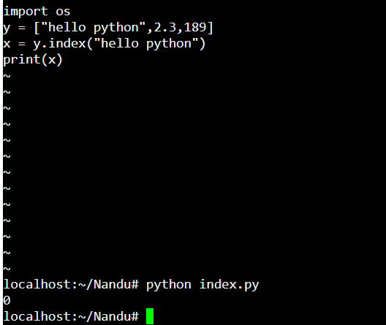

8.Remove : it is used to remove the specific element/value in the list by giving element/value name .

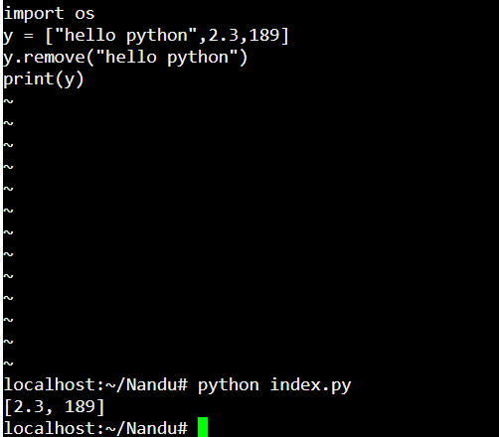

9.Reverse : it is used to reverse the entire list.

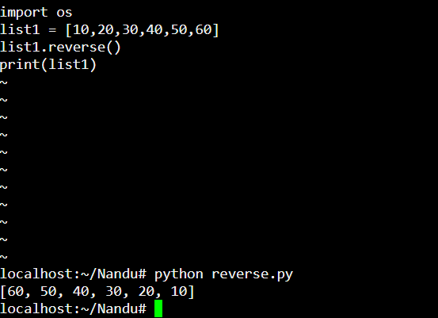

10.Pop: it is used to display the particular given element in the list by giving the index position. If not given it will display the last element of the li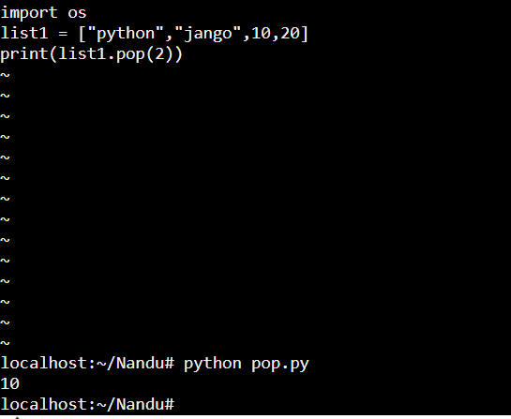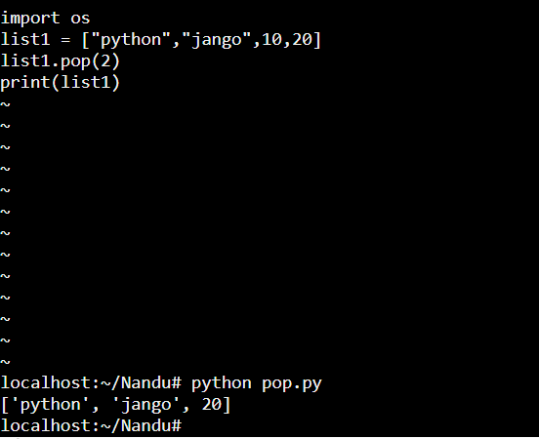

if you give pop function in extra line it will **remove** the particular element from the list by giving the indexing position of the element.

11.Sort : it is used to sort in a particular order either ascending order.

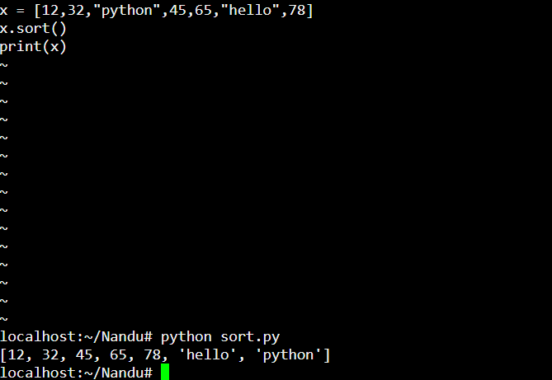

12.Sum : It used to calculate the total elements in sum of a list.

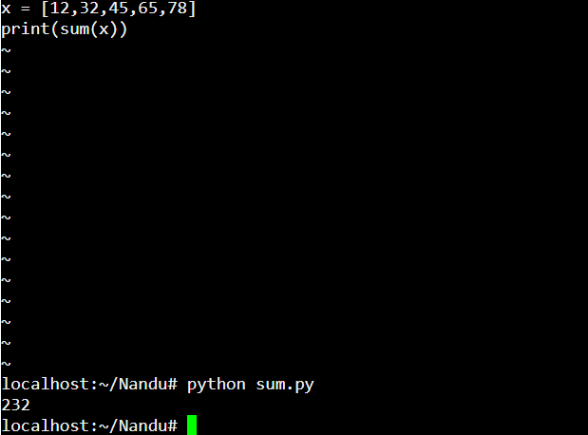

13.Min: it is used to calculate the minimum element of entire list.

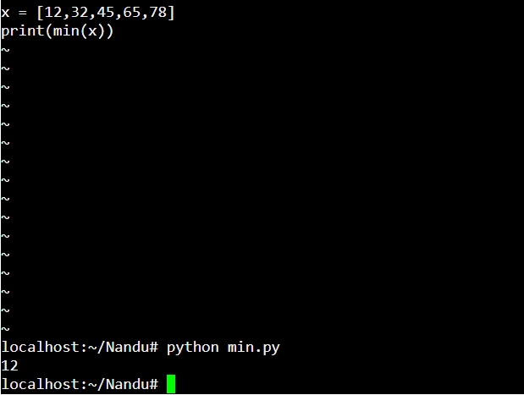

14.Max : it is used to calculate the maximum element of the list.

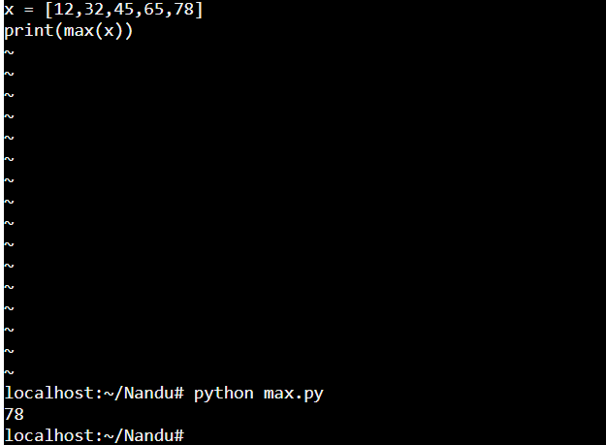

15.Delete: it used to delete the particular index value/element by giving the index position

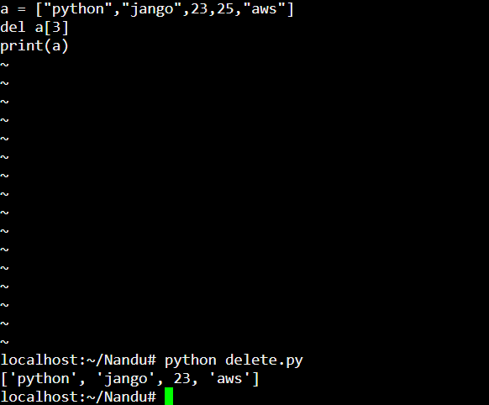

16.Copy: it is used to copy the old list elements into the given new list without changing the old list elements.

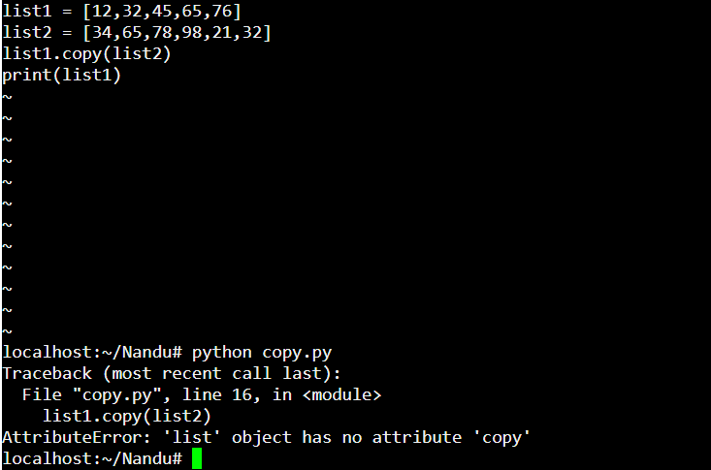

Tuple : It is same as list, it can’t be changed and it has group of elements are separated by comma (,)

Tuple allows duplicate elements , elements are used using index starting with 0 and in reverse index starting with -1.

EX :

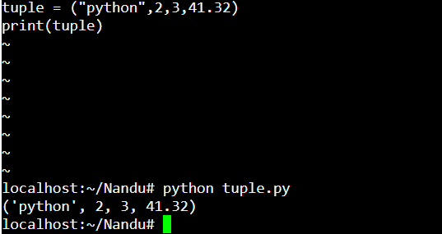

Methods:

1.Count : it counts the given number

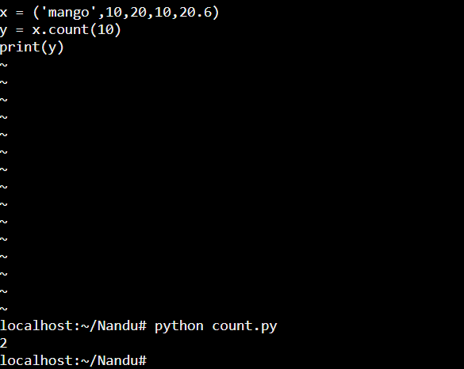

2.Index : it gives the index position of a given number .

